UML

UML full from unified modelling Language or it is a visualized language

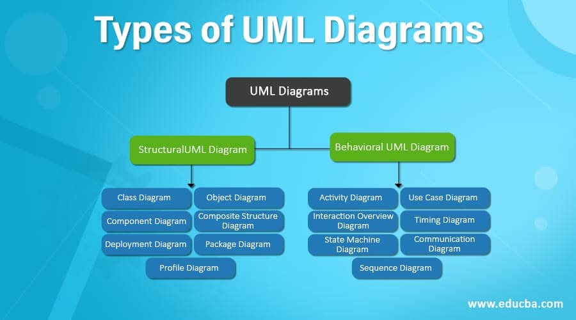

Class diagram not:

|  |
| --- |
| Class name |
| Class attribute |
| Class methord |

+ means public

-_ Private

# protective